MCG2101 – Intro Design of MCG Systems

Deliverable 4
Group 13

Names:
Haneen Barghouti
Lara Al Nakeeb
Emma Cochran
Linh Nguyen
Toshio Woo

Table of Contents
1. Progress Report 4
1.1. Locomotion 4
1.2. Sampling Mechanism 5
1.3. Buoyancy System 5
1.4. Structure and Wear Resistance 6
1.5. Stability System 7
1.6. Assembly 8
2. References 9
3. Appendix 10

List of Figures:
Figure 1. Klann Mechanism 10
Figure 2. Sketch of Locomotion Subsystem 10
Figure 3. Bearing for Legs 11
Figure 4. Inside and Outside Bar Links for Bearing 11
Figure 5. Klann Linkage CAD 12
Figure 6. Sampling Mechanisms 12
Figure 7. Variable Buoyancy System CAD 13
Figure 8. Structure & Wear Resistance 14
Figure 9. Friction Pad Front and Section View 14
Figure 10. Assembly CAD Isometric View 16
Figure 11. Assembly CAD Bottom View 16

Progress Report
The progress for this week was centered around defining requirements, identifying concepts, and making rough sketches and models. This progress was kept track of in the Gantt chart featured as Figure 13 in the appendix.

Locomotion
Refer to Figure 1-5 in the appendix.
To complete the tasks for this week, the primary objective was to create a simple Klann mechanism which could then be altered and iterated to produce a locomotion mechanism suited for this specific mandate. In order to get started, the dimensions for a typical Klann mechanism were required and retrieved from DIYWalker [1]. This website also provided a python script to virtually simulate a Klann mechanism’s movement depending on different bar lengths, as seen in Figure 1 in the appendix.
Once the requirements for the Klann linkage were determined and could be iterated according to restrictions on the size of the frame and the stability system, the next step was to sketch a practical implementation of the Klann mechanism as a guiding idea of how to proceed with CAD modelling. This sketch consisted of the general Klann linkage layout with sample dimensions, and a view of one of the pins which would use a bar and bearing assembly.
With an engineering sketch as a guide, it was possible to begin CAD development. To develop the bearing, a tutorial was followed and altered according to the needs of this project [2]. Following the development of the bearing assembly (Figure 3), inside and outside bars were made to fit onto the bearings allowing smooth rotation (Figure 4). Finally, once these were made for each part of the Klann linkage, they were made into a preliminary assembly showing how each bar would fit together (Figure 5).

Sampling Mechanism
Refer to Figure 6 in the appendix.
This week, a more thought-out design for the sampling mechanism was created. This included identifying what samples would be collected, which was decided to be sediment from the riverbed. Once this was determined, we were able to begin the design in more detail. The method of collecting sediment, filtering out water, and raising and lowering the chamber were all identified. Rough dimensions were also determined based on the size available in the crab body and the length of the legs. A rough design was then sketched on paper (see Figure 6).
The main component of the sampling mechanism is the Archimedes screw and chamber. The helix will rotate, bringing sediment up the cylinder to the top. As the turning helix brings more sediment up, the particles will compact, squeezing out water through the filter in the chamber. The cylinder will be raised and lowered by a Scott-Russel linkage, involving another motor and a slider. The entire mechanism will be housed in the bottom of the crab body.

Buoyancy System
Refer to Figure 7-8 in the appendix.
To create a crab that has precise vertical control and uses minimal energy consumption a buoyancy system must be designed. The system must allow the crab to submerge, float, and ascent/decent. The system must be compact and fit within the body of the crab. It was also important that the buoyancy system is minimally disturbed and reuseable.
The buoyancy system created is a sealed internal reservoir. The internal reservoir contains a gas that can be compressed using a piston arm. The piston is the main separator from the lake water and the air. When the crab needs to ascend the piston arm will retract backwards decreasing the pressure of the air and pushing the lake water out. The piston displaces the water and the air takes up more volume, therefore the buoyant force increases and allows the crab to float upwards. The adjustable piston arm allows the vertical motion to be adjusted as necessary for emergency surfacing or diving through the water-to-air ratio.
The internal reservoir is built to fit in the main body/shell of the crab while considering space for the sampling mechanism. The SolidWorks model features a piston arm highlighted in blue and a red force arm; both are coloured to clearly distinguish components.

Structure and Wear Resistance
Refer to Figure 9 in the appendix.
During this stage of the project, much progress was made over the initial structural design of the crab. First was the overall size and scale of the crab were established. Key dimensions (length, width and height) were defined to ensure the model met realist crab criteria. Next, a basic body geometry was created in SolidWorks. The main shell structure was developed to create a clean and simple model that we can later add to with additional details. Made progress in the mounting locations for the legs as well and positioned them with proper spacing so as not to have an overlapping happen. For the motion of the legs, space was given to make sure no interference happened while the legs were in motion.
The structure of the crab body consists of two compartments where the buoyancy system and sampling mechanism will be stored. It was ensured that the measurements of these components will be able to fit in the crab body and not interfere with one another. Based on the feedback received, we focused mostly on the integration of the subsystems with the shell rather than the materials used to minimize wear.
The European green crab can be 7-10 centimeters which was considered when making the shell [3]. To ensure the buoyancy and sampling systems can fit and function in the shell, the 10-centimeter size was chosen.

Stability System
Refer to Figure 10 of the appendix.
The friction pad added to the end of each leg has progressed from an initially flat, rectangular design to a hemispherical pad. This design considers the movement of the crab legs as the hemispherical design allows for smooth movement on the seabed. This shape also causes less disturbance to the seabed than a rectangular design with harsh edges. This idea was found to be used in space exploration landers [4]. A ball and socket joint were also added to account for the Klann linkage movement in the legs. The pad will not be restricted in angular movement this way which allows for adaptation to uneven terrain, and the small spikes allow for increased grip. The connection to the leg was also considered. The ball and socket joint will double as a “sleeve” for the bottom of the leg to fit and screw into. This way, the movement of the Klann linkage will not be affected by the addition of the friction pad. The diameter of the pad was chosen as 3cm to ensure proper spacing between each. However, since adjacent legs will be offset in motion, the pads should not come in contact with each other.
The friction coefficient of rubber on wet rock (estimated from rubber on wet asphalt) was found to be 0.25 – 0.75 which will later be used in frictional force verification once the final mass is confirmed [5].

Assembly
Refer to Figures 11-13 of the appendix.
While most of the progress in this early stage was focused around developing the subsystems independently, an assembly sketch and assembly CAD model was made as a rough design to guide future models. These designs incorporate simplified versions of each of the subsystems into a single drawing to help identify any issues with incorporation early on.

References
[1] Ben and Wade, “Klann Linkage Optimizer,” DIY Walkers. Accessed: Mar. 01, 2026. [Online]. Available: https://www.diywalkers.com/klann-linkage-optimizer.html
[2] CADOMANIA, How to design a Bearing in SolidWorks: From Sketching to Rendering #cad #solidworks #mechanical, (Apr. 14, 2023). Accessed: Mar. 01, 2026. [Online Video]. Available: https://www.youtube.com/watch?v=wv4t687ro8A
[3] F. and O. C. Government of Canada, “European Green Crab.” Accessed: Mar. 01, 2026. [Online]. Available: https://www.dfo-mpo.gc.ca/species-especes/profiles-profils/europeangreencrab-crabevert-eng.html
[4] W. Dou, X. Qiu, Z. Xiong, Y. Guo, and L. Zhang, “A Footpad Structure with Reusable Energy Absorption Capability for Deep Space Exploration Lander: Design and Analysis,” Chin. J. Mech. Eng., vol. 36, no. 1, p. 93, Aug. 2023, doi: 10.1186/s10033-023-00918-1.
[5] “Friction - Coefficients for Common Materials and Surfaces.” Accessed: Mar. 01, 2026. [Online]. Available: https://www.engineeringtoolbox.com/friction-coefficients-d_778.html

Appendix
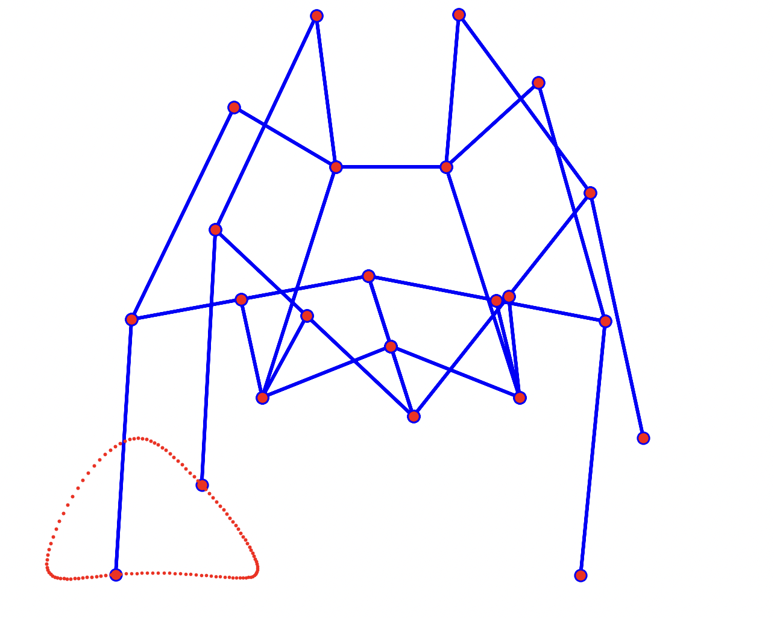
Figure 1. Klann mechanism

Figure 2. Sketch of locomotion subsystem
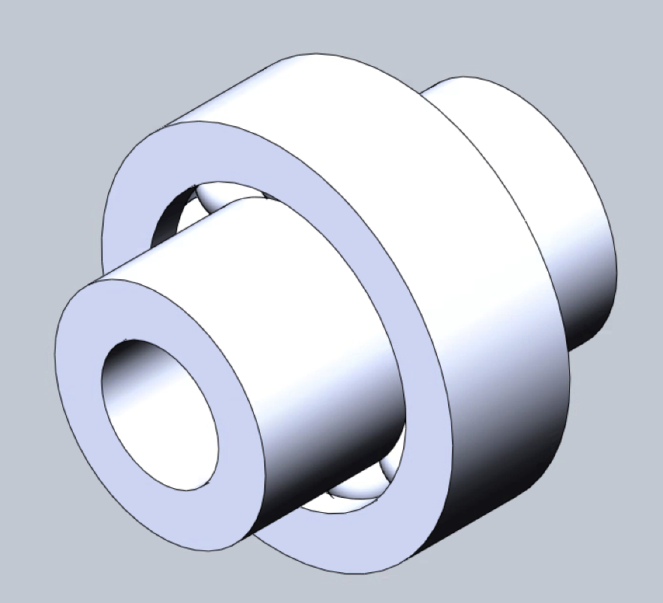
Figure 3. Bearing for legs

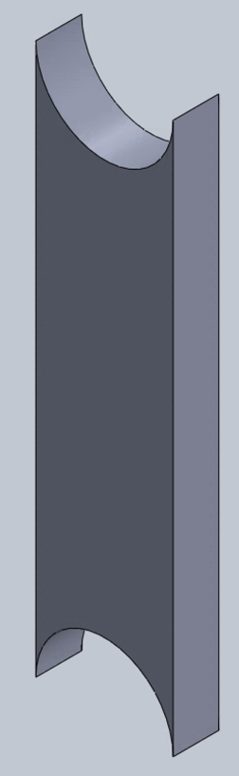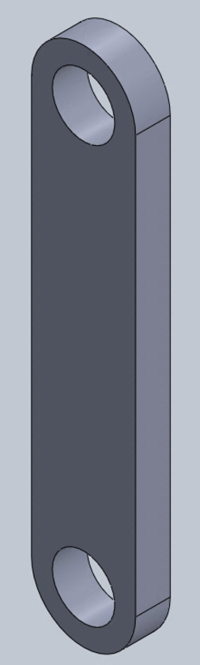
Figure 4. Inside and outside bar links for bearing

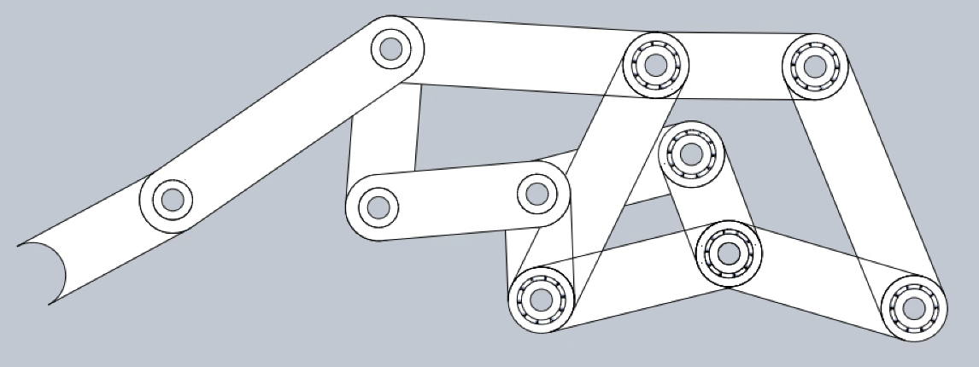
Figure 5. Klann linkage CAD

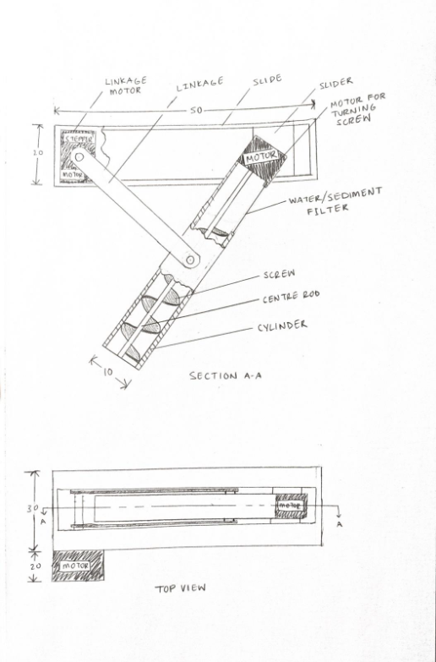
Figure 6. Sampling mechanisms
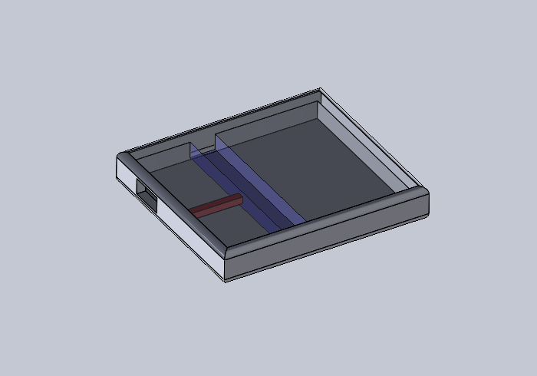
Figure 7. Variable buoyancy system CAD

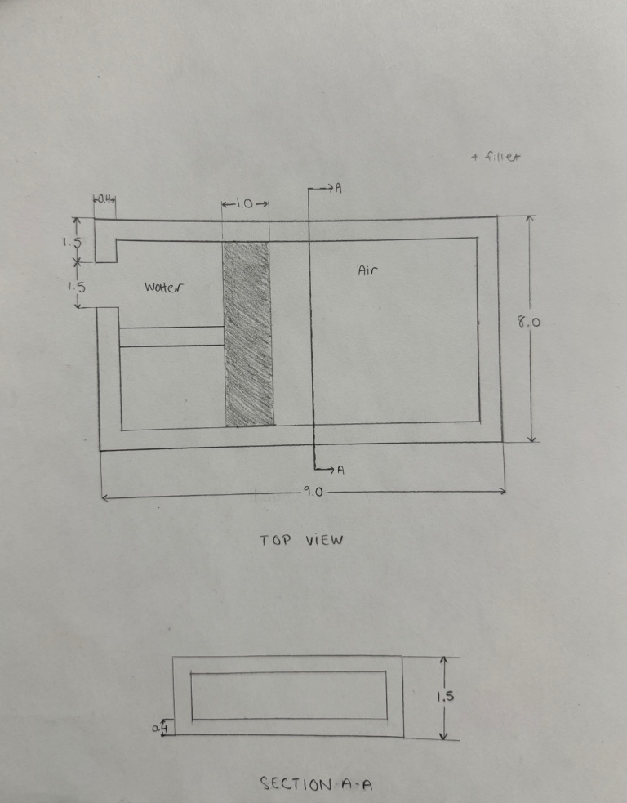
Figure 8. Variable buoyancy system sketch

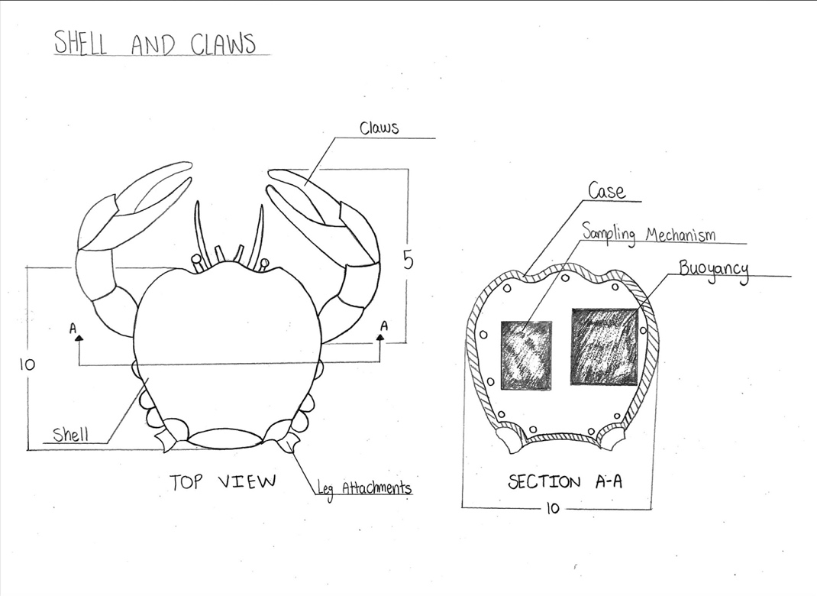
Figure 9. Structure & wear resistance
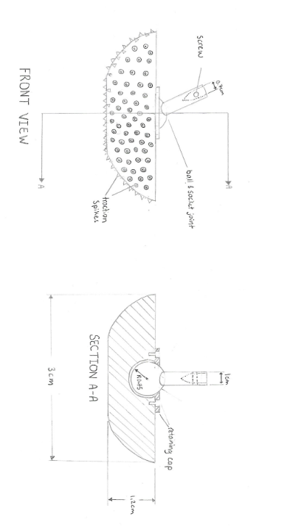
Figure 10. Friction pad front and section view

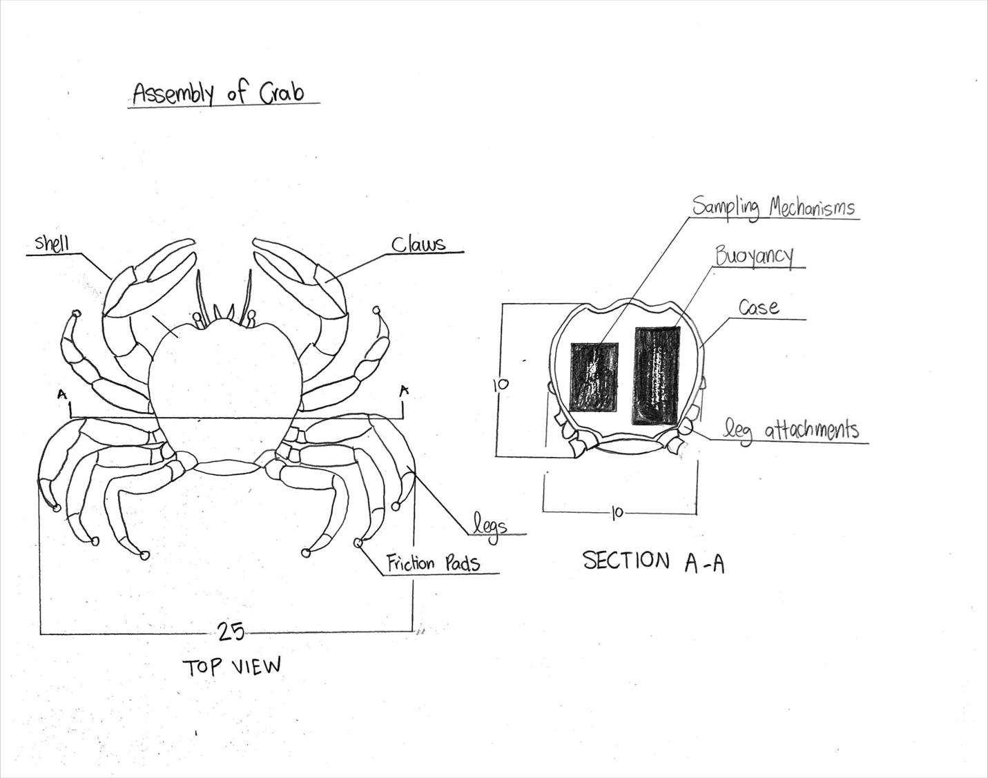
Figure 11. Assembly Drawing
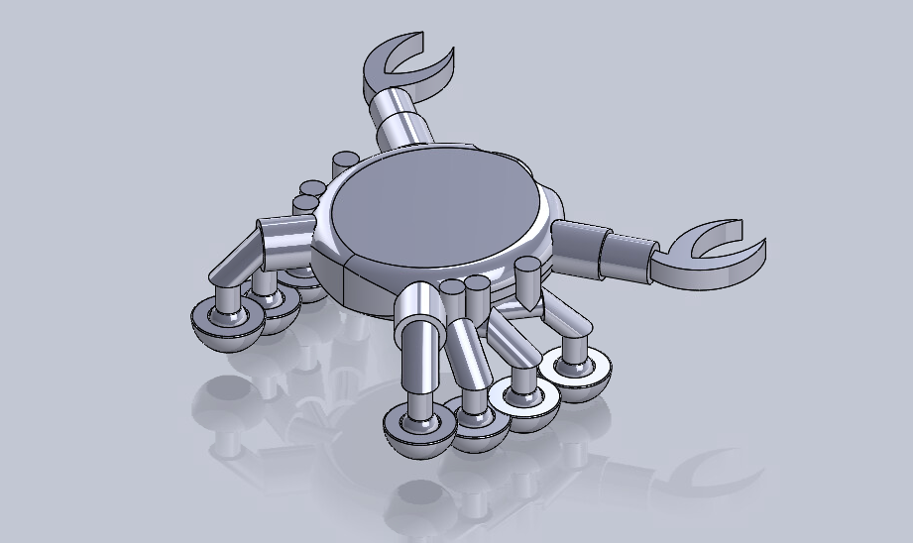
Figure 12. Assembly CAD isometric view

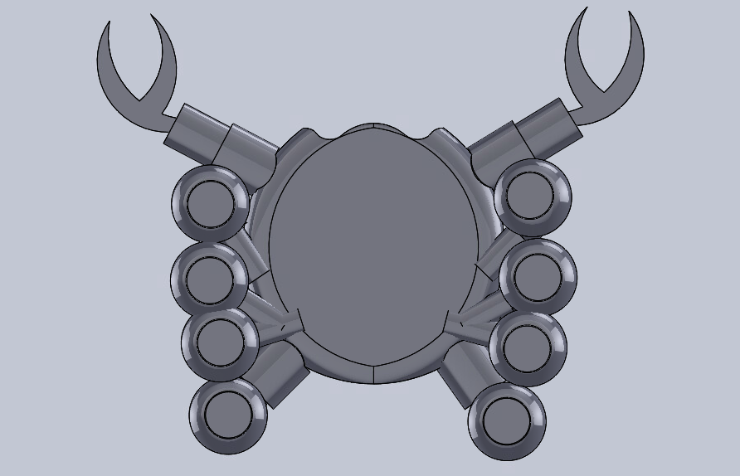
Figure 13. Assembly CAD bottom view

Figure 14.1 Gantt chart (part 1)
Figure 14.2 Gantt chart (part 2)

Figure 14.3 Gantt chart (part 3)

